H&S-EUF25 – Working from Home Risk Assessment

Name: …………………………………………………………………………………………………………
Date completed: …………………………………………………………………………………………
Assessment checked by: ………………………………………………………………………………
Further action needed?: YES / NO
Action completed on: ……………………………………………………………………………………
__________________________________________________________________________________
This risk assessment is put together to assist you in assessing the health and safety of your home working environment. It is intended to cover the area(s) of your home that you will use to carry out your office work.
Work through the following checklist and tick either ‘yes’ or ‘no’ against each item.
- ‘yes’ = no further action required
- ‘no’ = this will require investigation/discussion, and the decision should be recorded in the ‘comments/action’ column.

Consideration | Yes | No | Comments/ Actions
1.0 Working Environment
Is your working area suitable in terms of heating, lighting, noise and ventilation?
Do you have sufficient space to work?

Can you confirm that there are no slip/trip/fall hazards (such as trailing cables)?
Are there sufficient power outlets?

2.0 Communication
Have you determined a point of contact while you are working from home (i.e. line manager) and a frequency for this communication?
3.0 Display Screen Equipment Workstation
3.1 Display Screens
Are the characters clear and readable?
Make sure the screen is clean, and check that the text and background colours work well together.
Is the text size comfortable to read?
Software settings may need adjusting to change size.
Is the image stable (free of flicker and jitter)?
Try using different screen colours to reduce flicker, e.g. darker background and lighter text.
Is the screen’s specification suitable for its intended use?
Is the screen free from glare and reflections?
You might need to move the screen or even the desk and/ or shield the screen from the source of the reflections. Screens that use dark characters on a light background are less prone to glare and reflections.
Are adjustable window coverings available (to reduce glare/reflections)?
3.2 Keyboards
Is the keyboard separate from the screen?
This is a requirement, unless the task makes it impracticable (e.g. where there is a need to use a portable laptop).
Is it possible to find a comfortable keying position?
Try pushing the display screen further back to create more room for the keyboard, hands and wrists. Users of thick, raised keyboards may need a wrist rest.
Are the characters on the keyboard clear and readable?
3.3 Mouse
Is the mouse suitable for the task(s) it is to be used for?
Do you have support for your wrist and forearm?
Support can be gained from, for example, the desk surface or arm of a chair. If not, a separate supporting device may help.
3.4 Furniture
Is the work surface large enough for all the necessary equipment, papers etc?
Can you comfortably reach all the equipment and papers you need to use?
Are surfaces free from glare and reflection?
Consider mats or blotters to reduce reflections and glare.
Are forearms horizontal and eyes at roughly the same height as the top of the DSE?
Is the chair suitable, supportive, stable and is it adjustable?
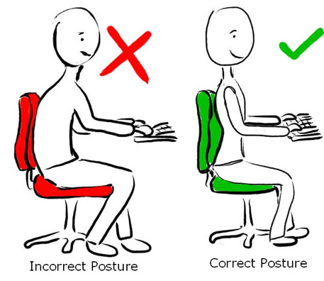

Are your feet flat on the floor, without too much pressure from the seat on the back of your legs?
If not, a footrest may be needed.

